Today’s Lecture Road Map
Dated: 21st May 2021
IOS Architecture
Android Architecture:
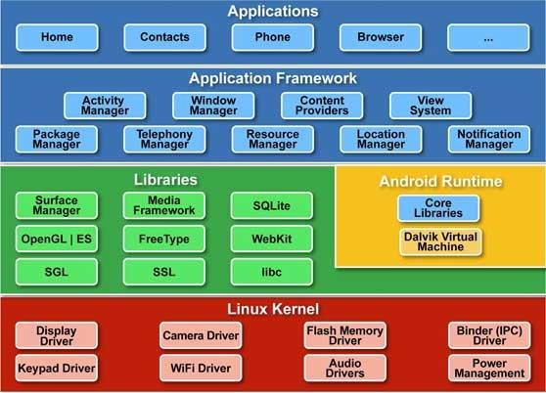

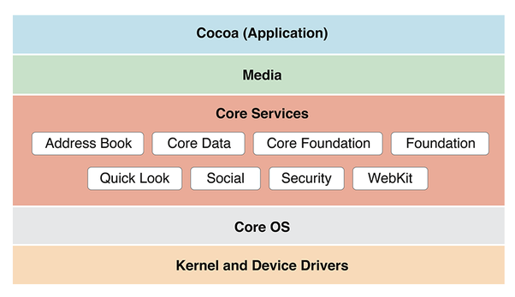

Application Bundle: A directory that contais all the app resources togrther
IOS = .app -> zipp ->.ipa
Inside .ipa
- Executable
- Information Property file Info.plist
- App icons (home Screen)
- Story Board (layout of the screens)
- Settings.bunlde
- Root folder that contains all the assets of the App (file)
Android Components: -> IOS
- Activity -> ViewController
- Services -> “Background Mode” + Different API Calls
- Intent -> Segues
- Content Provider -> Core Data
- Layouts -> StoryBoards and Scenes

Building Bloacks:
- UIApplication
- The main entry point for your app
- Each app has exactly one instance of this class
- Provides the main interface back to the OS
- Handles all incoming info from the OS (such as touch event, memory warnings,incoming phone call, etc.)
- Passes these messages off to UIApplication Delegate
- UIApplication Delegate
- Manages the running of your app
- Handles “major” events, like app switching, app initialization, etc.
- UI Document allows for internal app documents and data stores manages all views (scenes) for the app
- UIWindow: the one window of the iOS device (only have more if external display)
- View Objects: all the widgets in a scene
- ViewController: manages all views (scenes) for the app

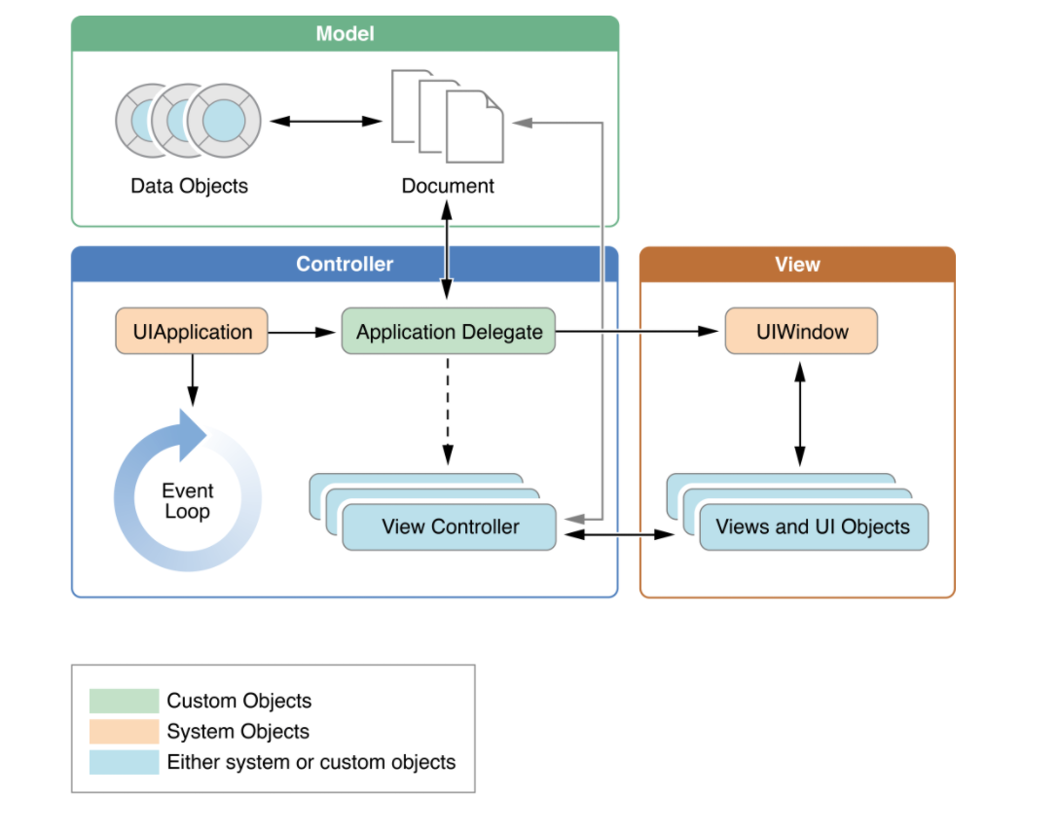

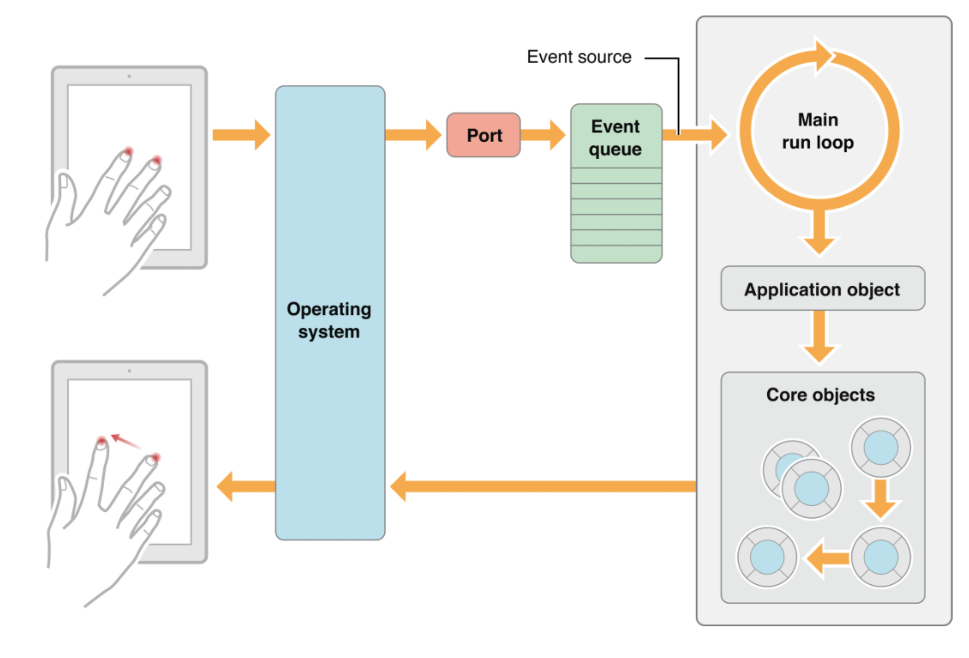
Tha Main App Loop
The OS receives input and passes it to the UIApplication -> UIApplicationDelegate -> UIWindow -> ViewController
- Other events are passed to the “First Responder” object that is available
- Everything that can accept and respond to an event is a responder object
- The first responder object is the top-level designated object in a view to handle events
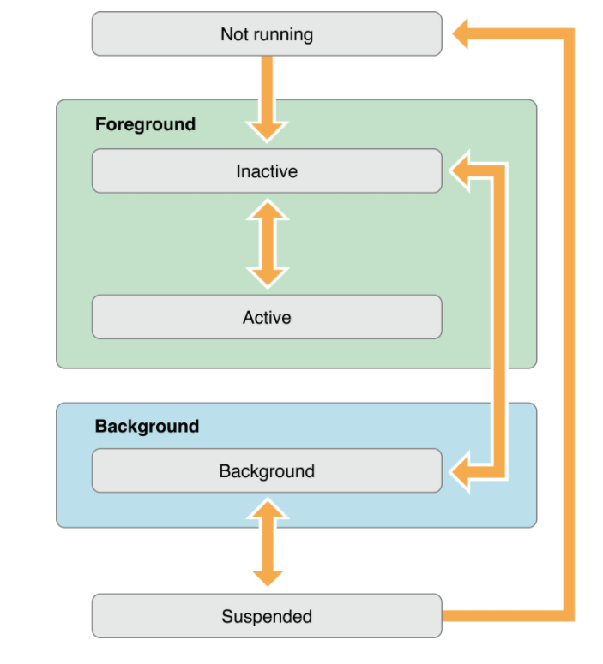
App States:

- applicationWillEnterForeground – starting to move to active state
- applicationDidBecomeActive – called right before view displayed
- applicationWillResignActive – first call before going into background
- applicationDidEnterBackground – now is in background
- applicationWillTerminate – will end
On Launch
- application comes in with didFinishLaunchingWithOptions
- Check dictionary launchOptions for info on why was launched (somewhat like looking at the Intent)
- Any app not responding in 5 seconds is killed
- Start initialization
- UIKit grabs first storyboard and ViewController

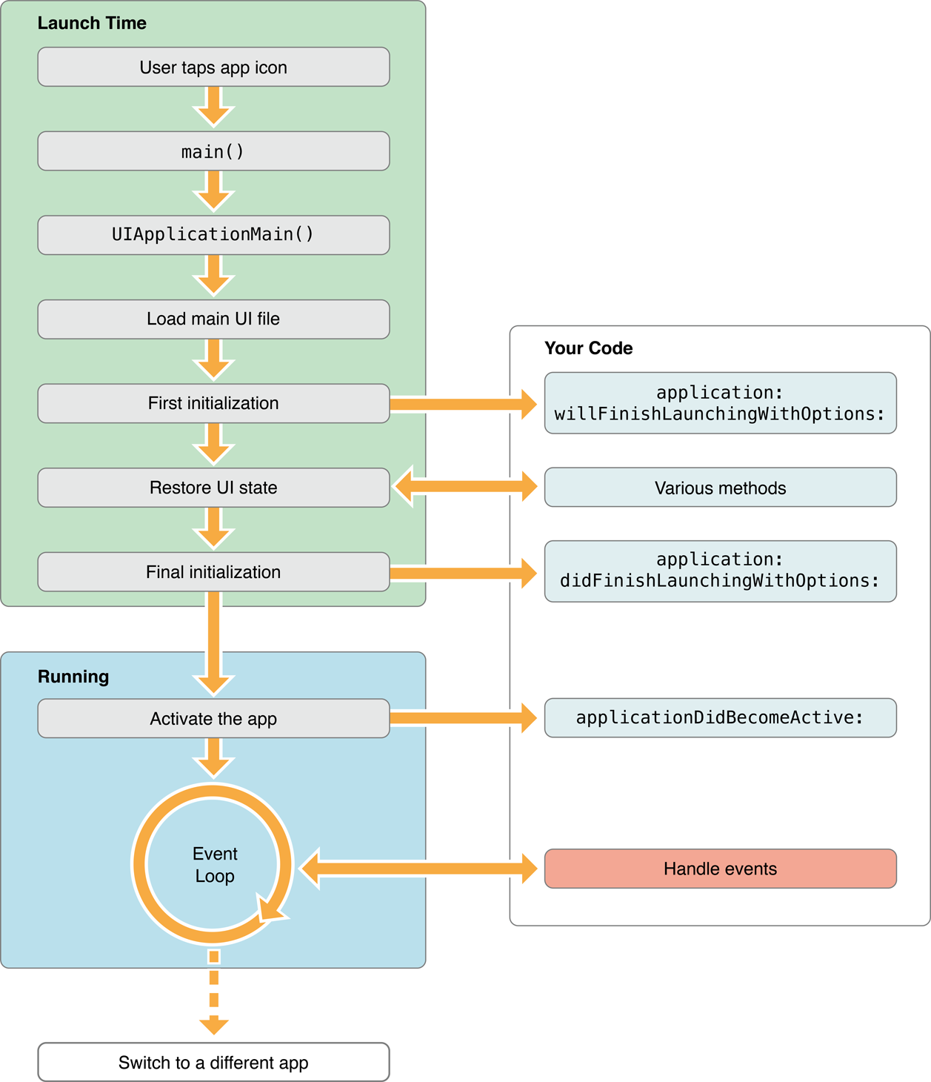

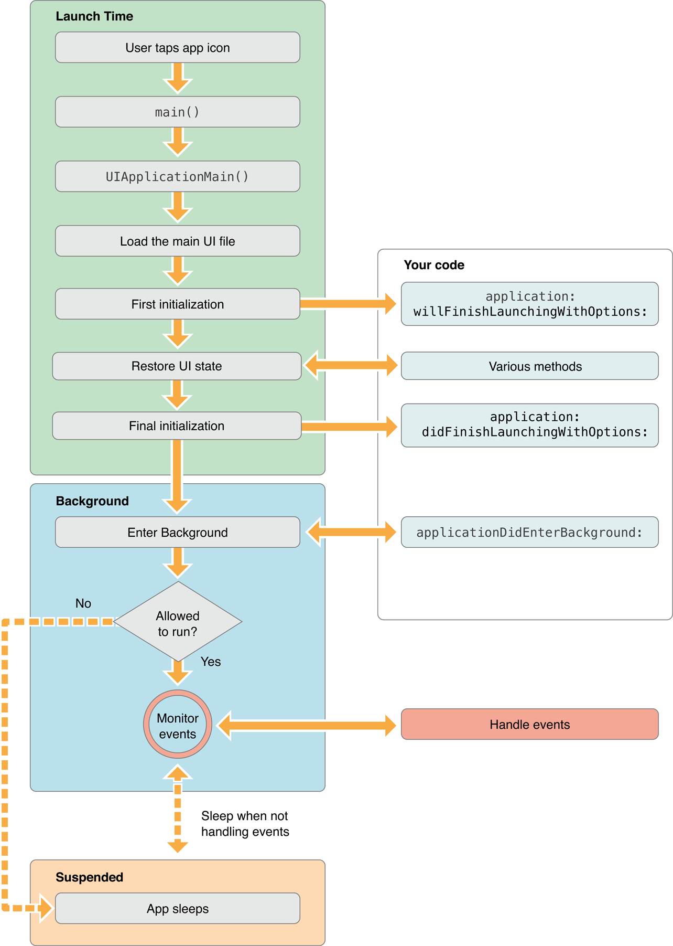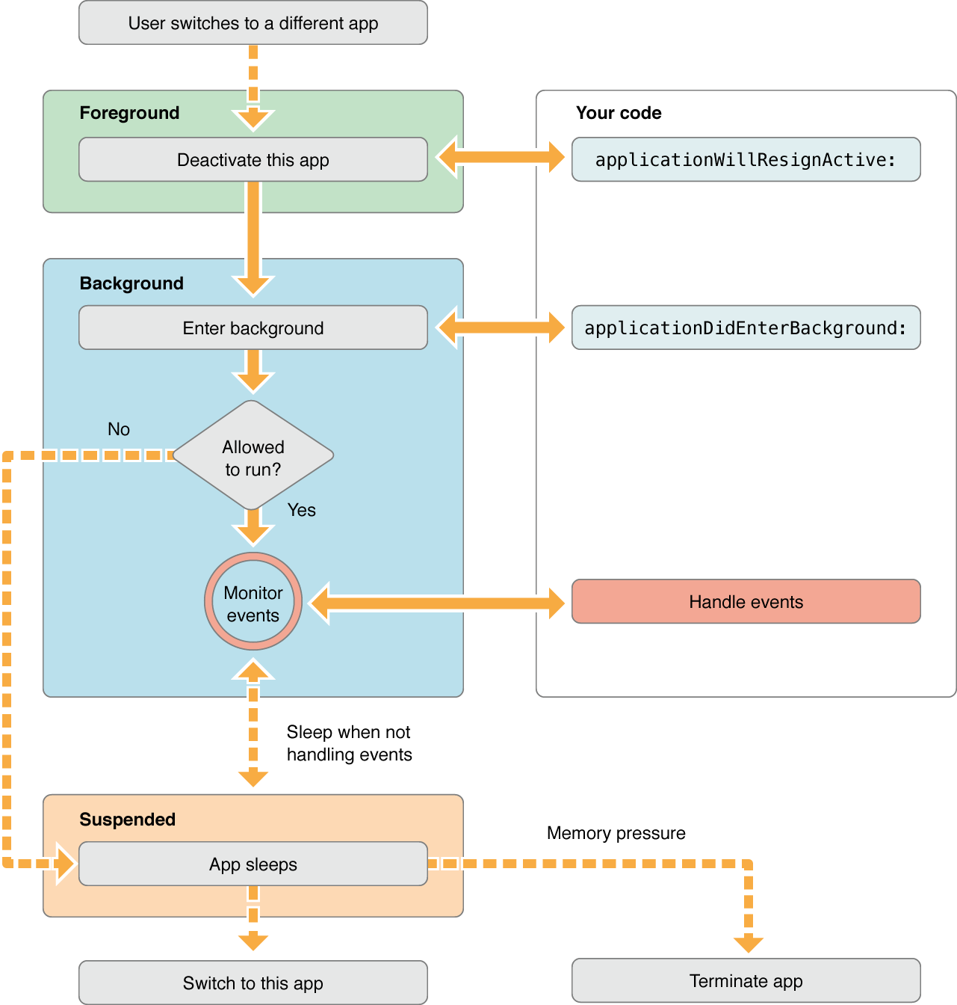

Inside the View

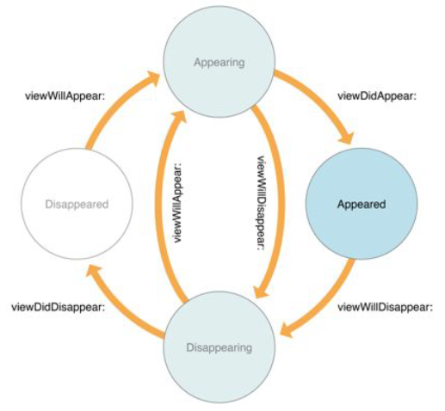

Images copies*

